|  |
| --- |
| **PROJECT REPORT**    **On**    **“AWS”**    **Submitted by**    **Saurabh Pundir**  181510028    Department of Computer Engineering & Applications  **Institute of Engineering & Technology**              **GLA University**  **Mathura- 281406, INDIA 2019** |

**ACKNOWLEDGEMENT**

The success and final outcome of this project required a lot of guidance and assistance from many people and I am extremely privileged to have got this all along the completion of my project. All that I have done is only due to such supervision and assistance and I would not forget to thank them.

I respect and thank **Mr. Ambrish Gangal**, for providing me an opportunity to do the project work in **AWS** and giving me support and guidance, which made me complete the project duly. I am extremely thankful to him for providing such a nice support and guidance, although he had busy schedule managing the corporate affairs.

Thanks

**Saurabh Pundir**

**(181510028)**

CONTENT

1. Launching of EC2 instance.

2. Setup of LAMP Server.

3. Static website.

**Launching of EC2 instance**

1. Open ec2 instance 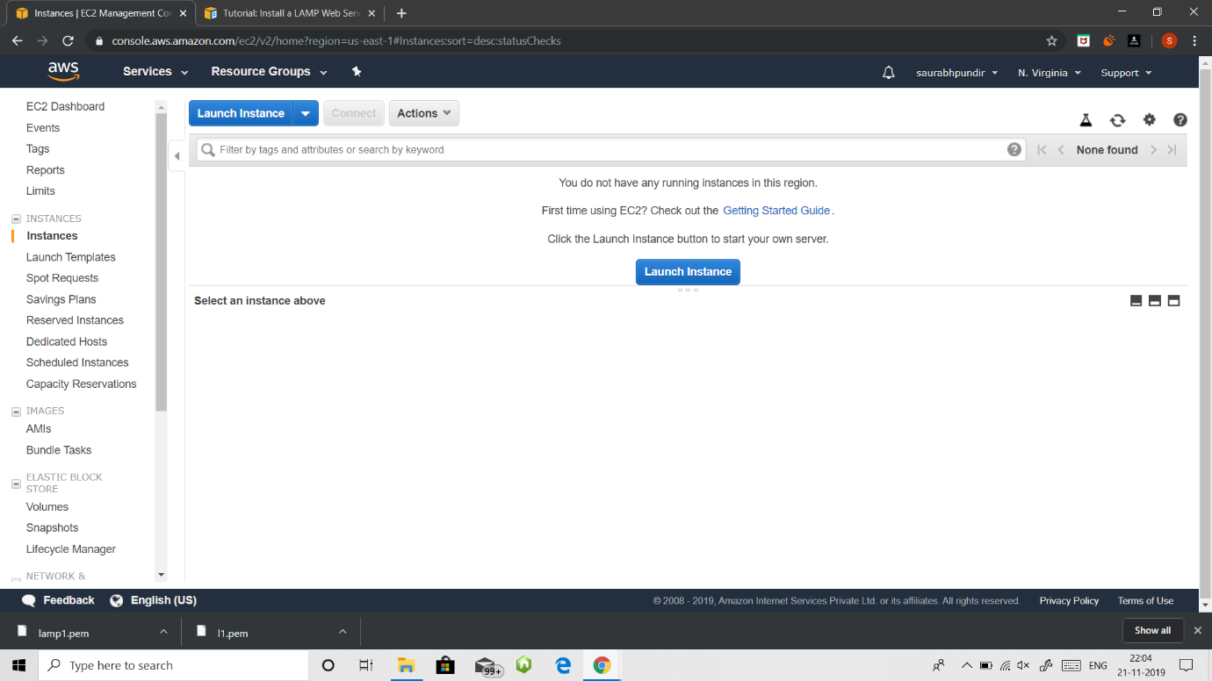

2. Select AMI

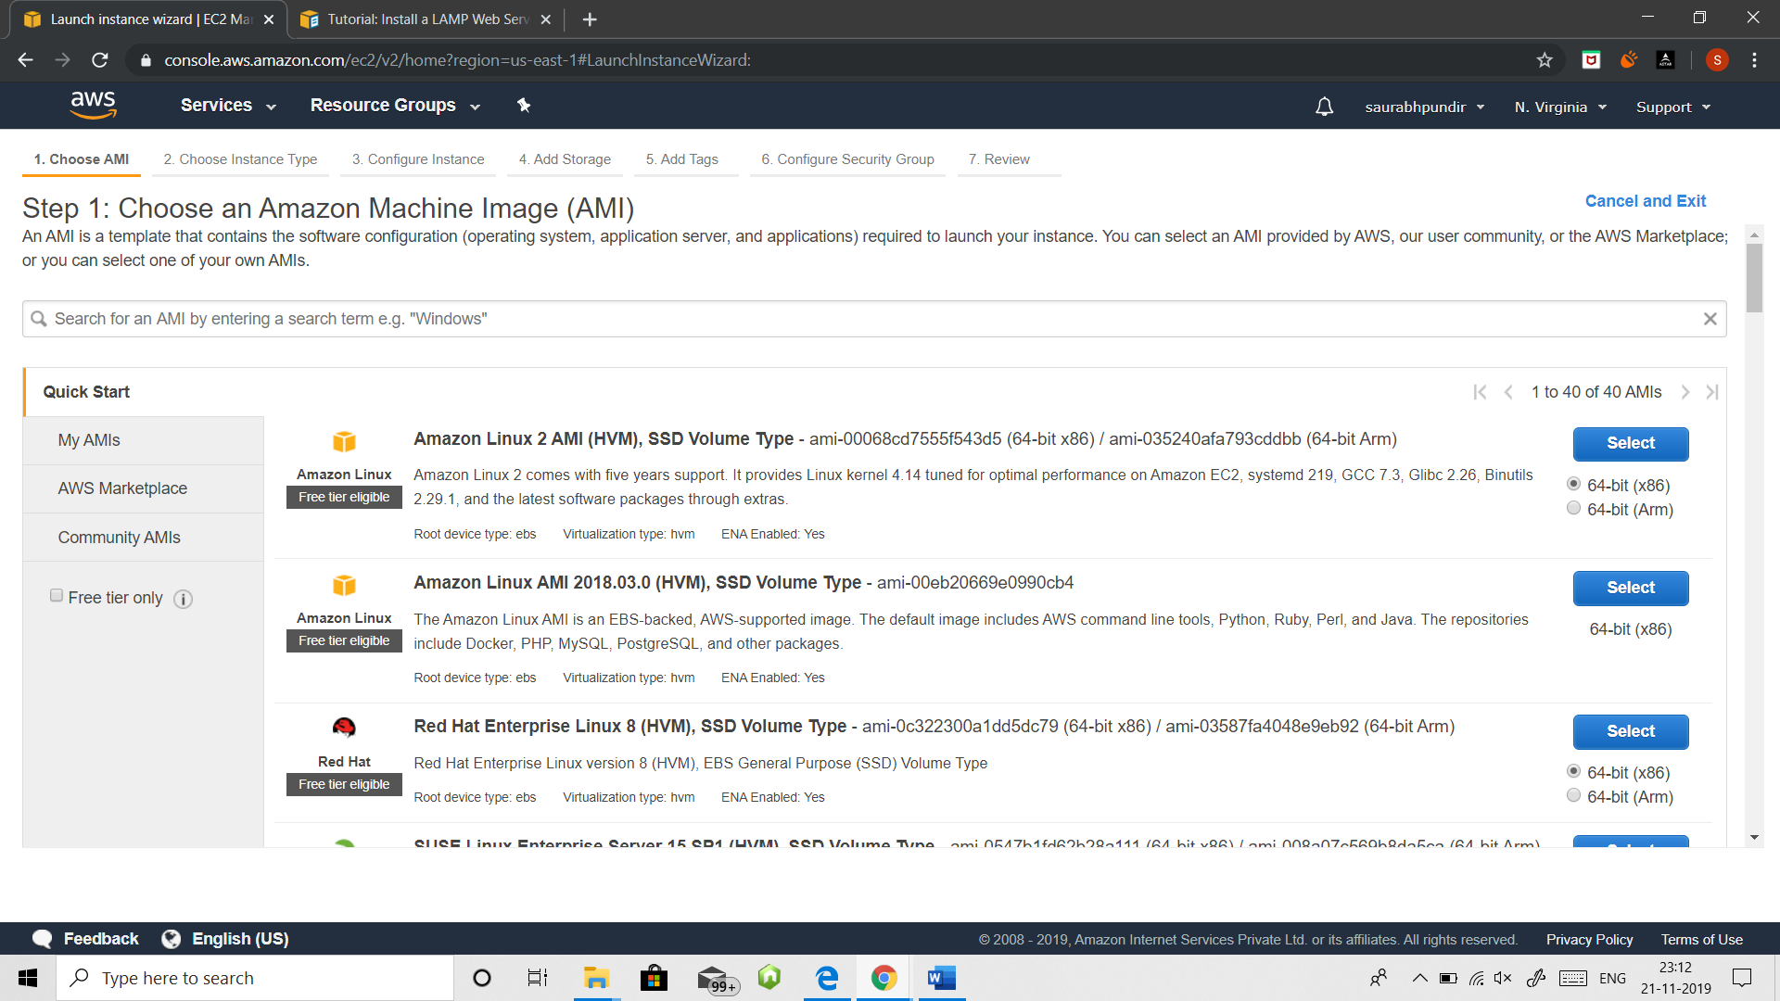

3. Choose instance type

Here we are choosing free tier eligible type.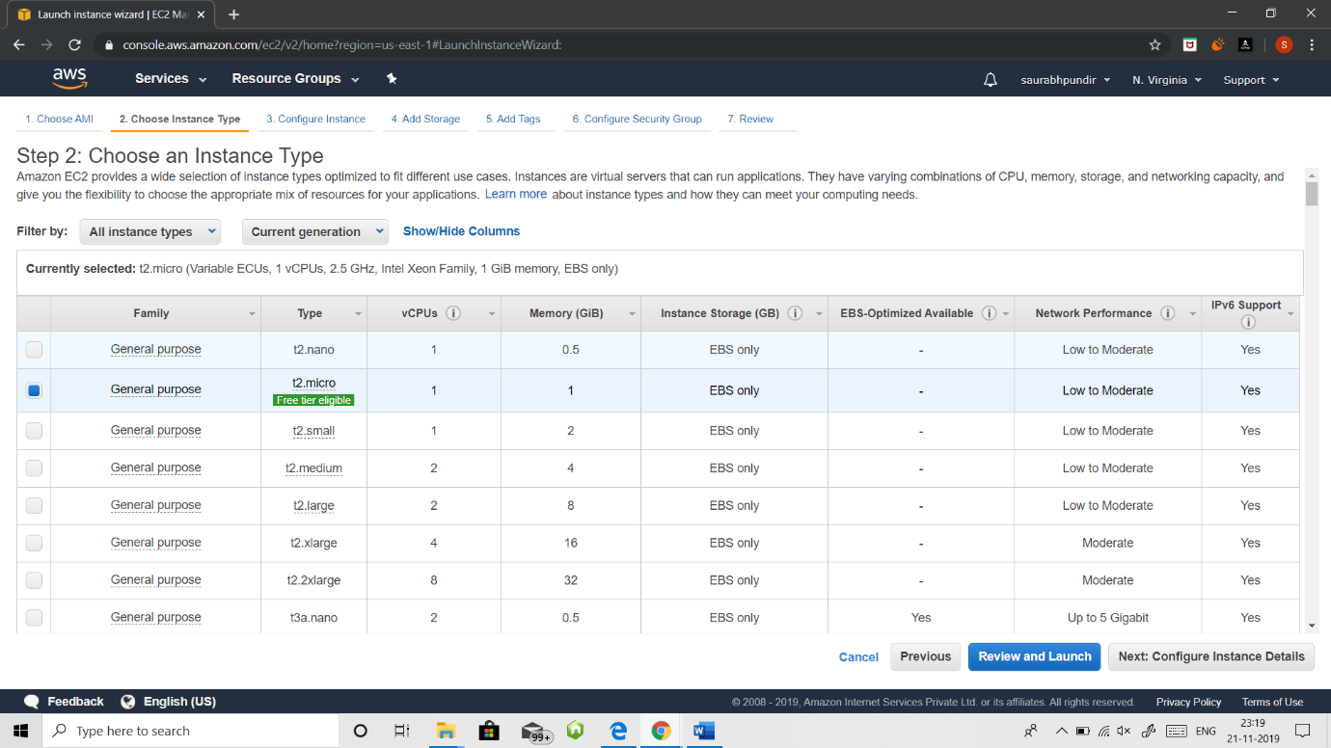

4. configure security groups

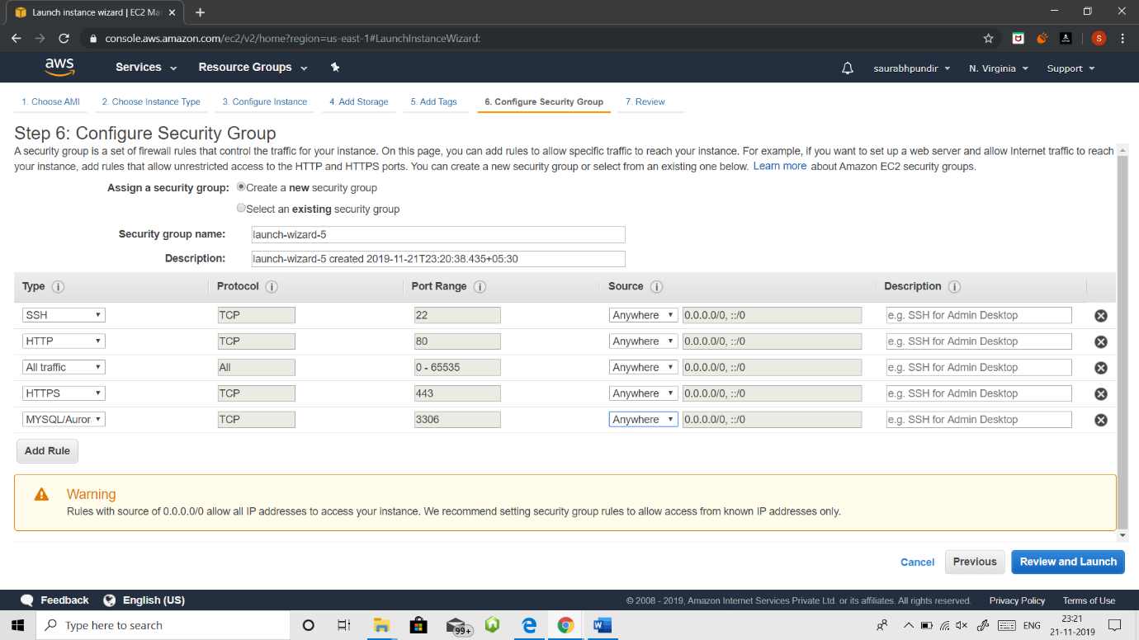

5. Review and Launch

Download key pair.

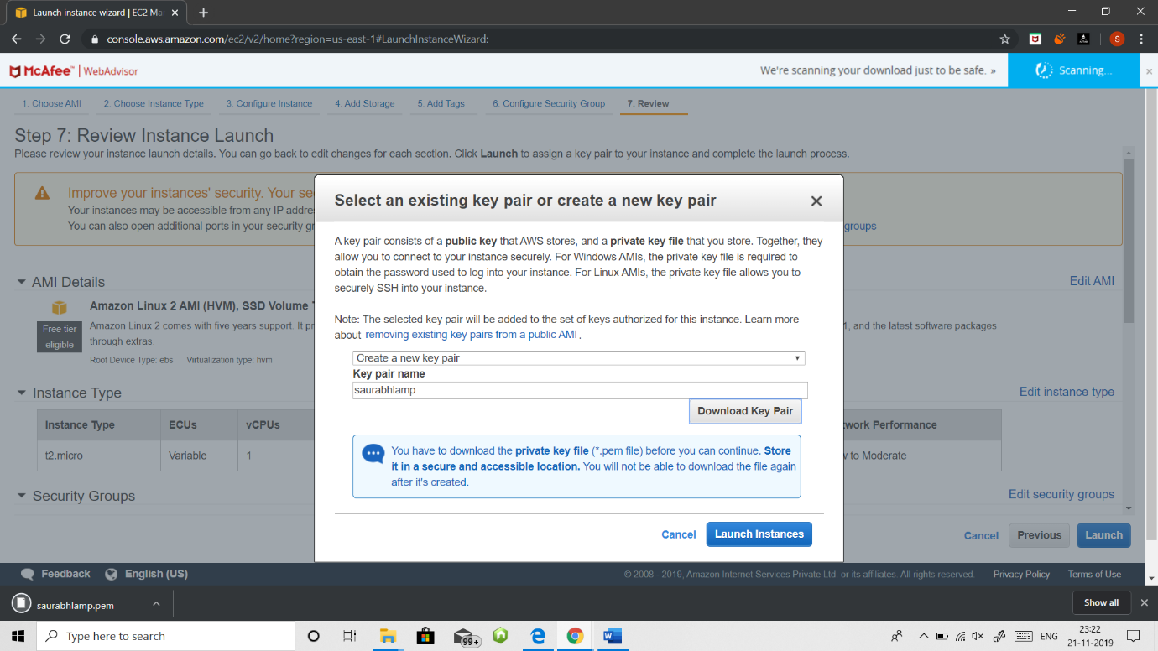

6. wait until instance status checks become 2/2 and instance state is running

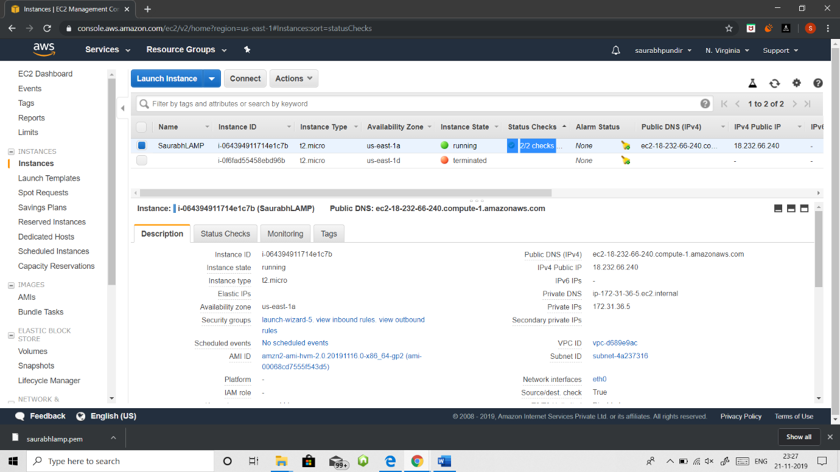

7. Open Putty KeyGen

Here we load the downloaded .pem file and save as private key which downloads in format of .ppk (named as saurabhLAMP.ppk)

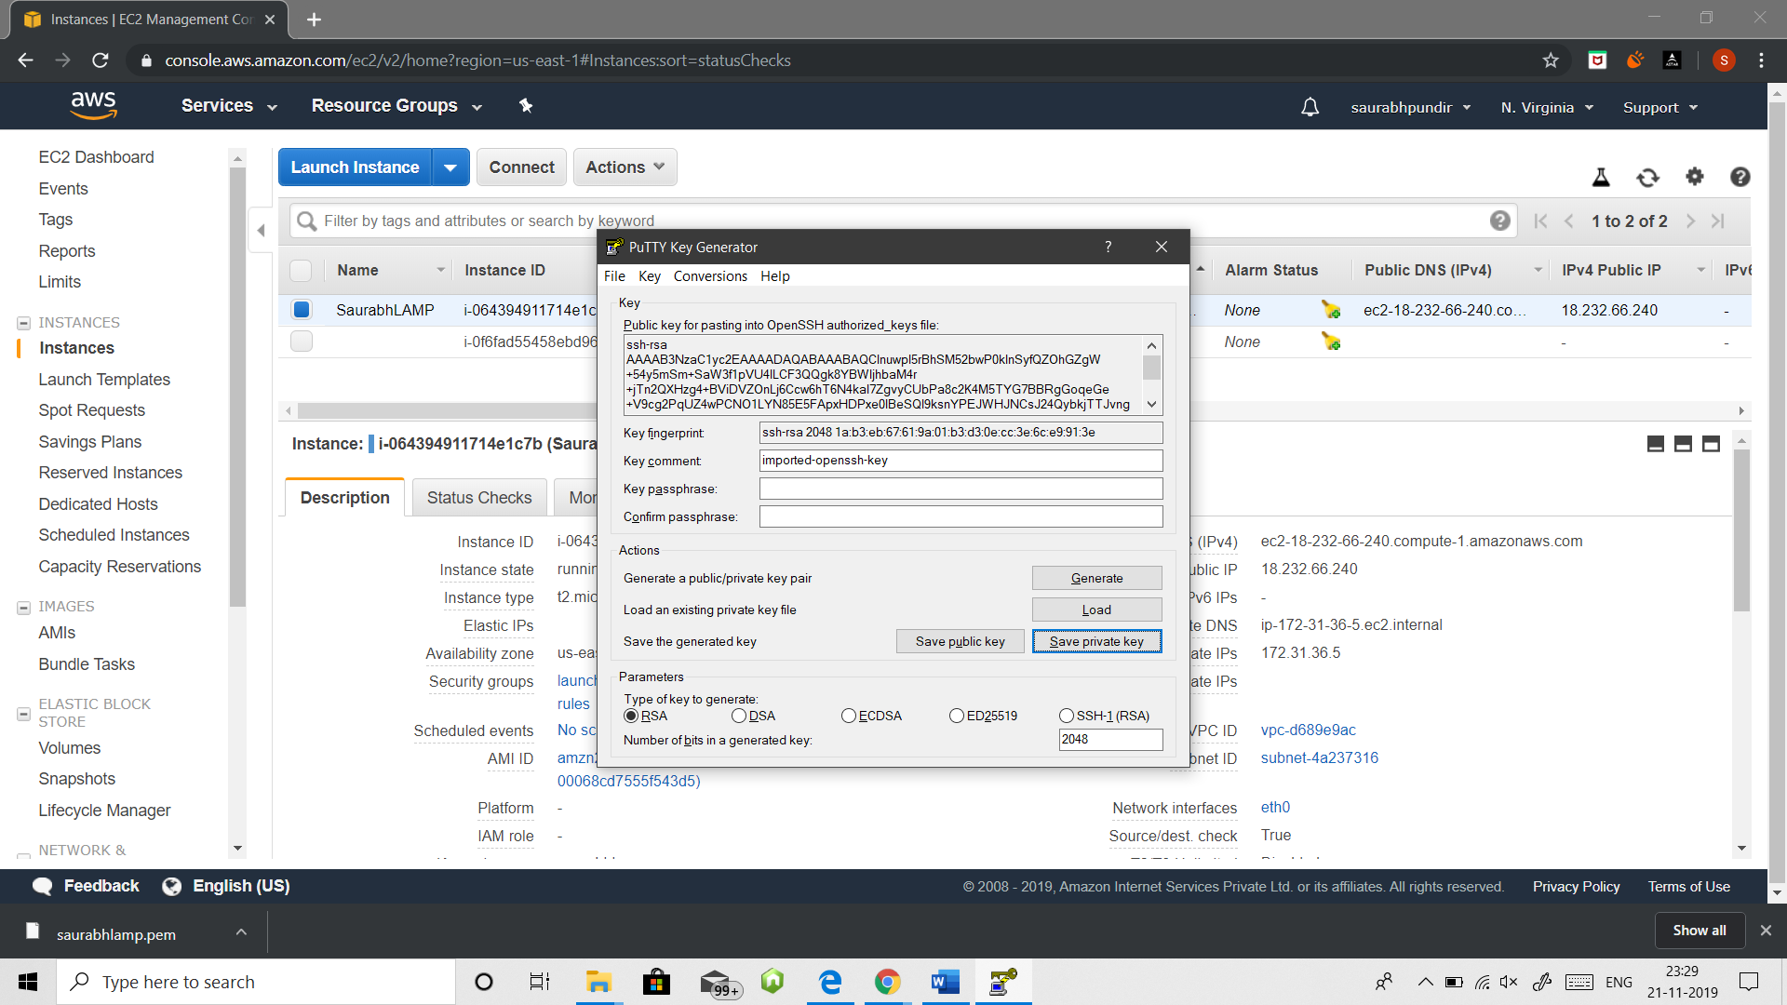

8. Open Putty

Here use your ipv4 as your host name

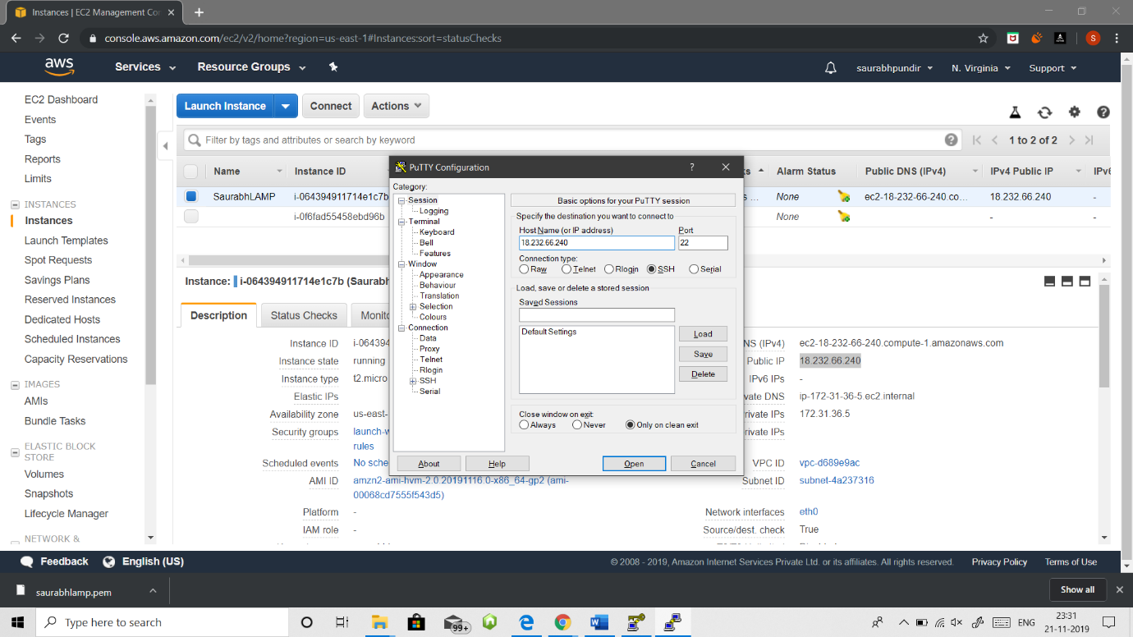

now in ssh=> auth browse your downloaded .ppk file and open it

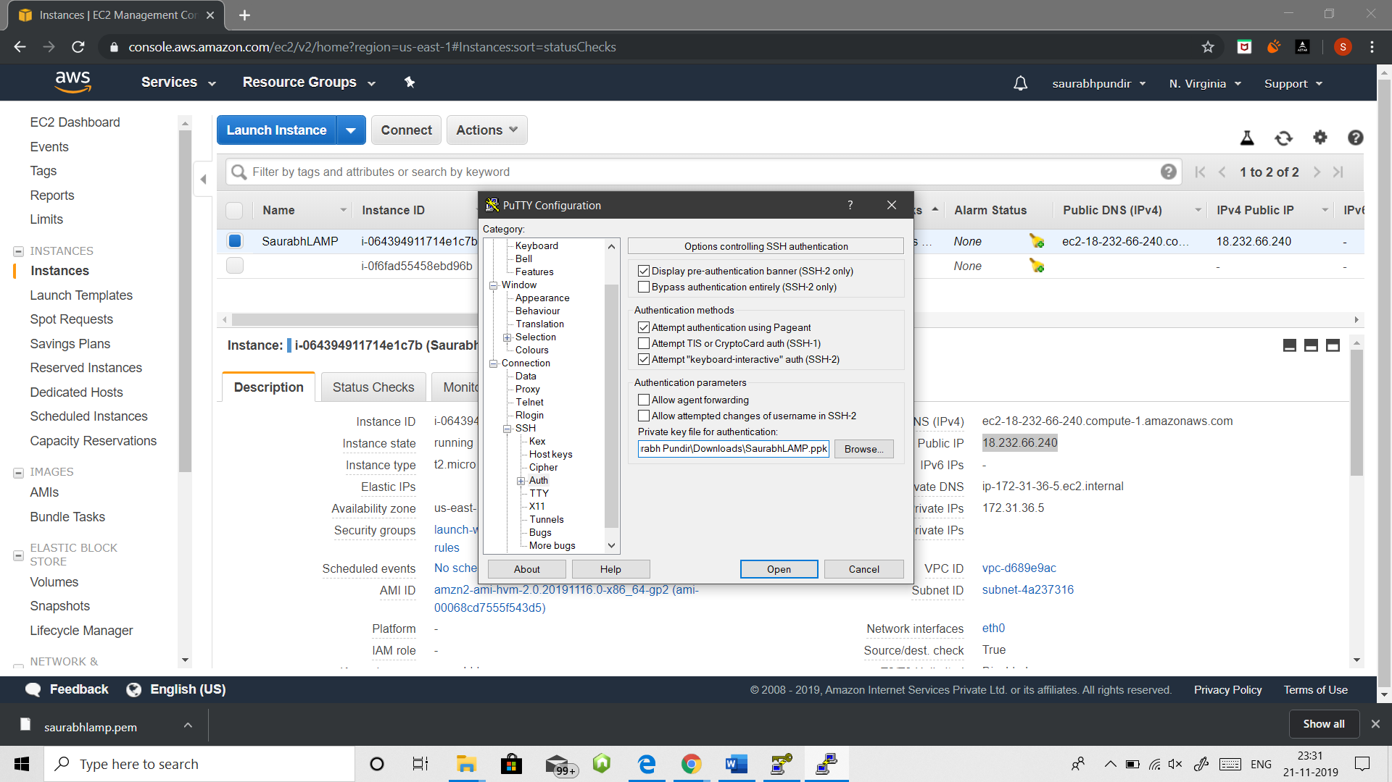

9. Login as: ec2-user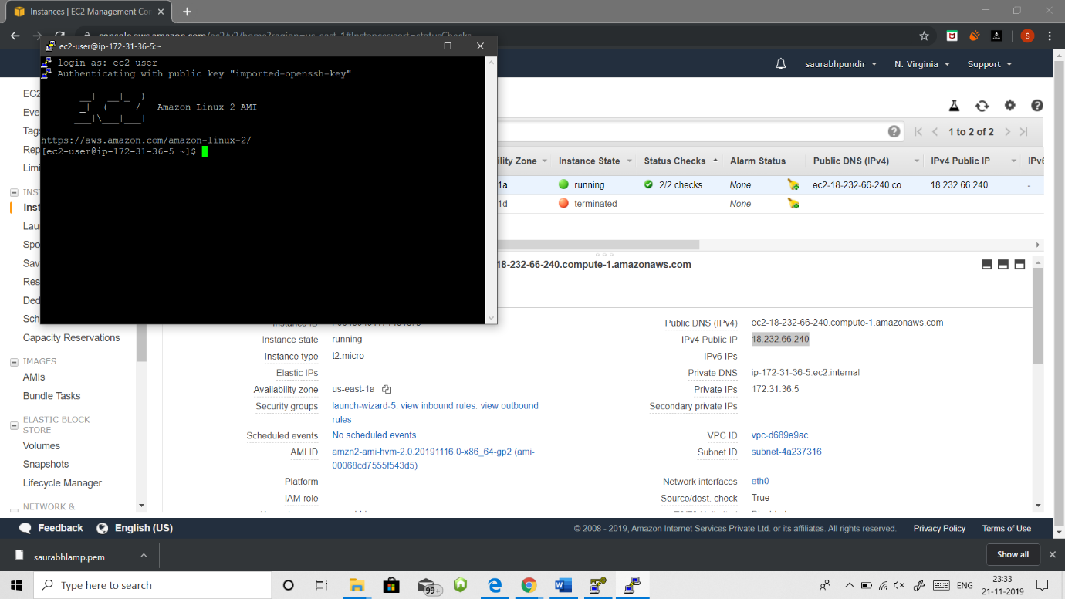

Instance launched

**Setting up LAMP server**

1. Now run the following command

a) sudo yum update

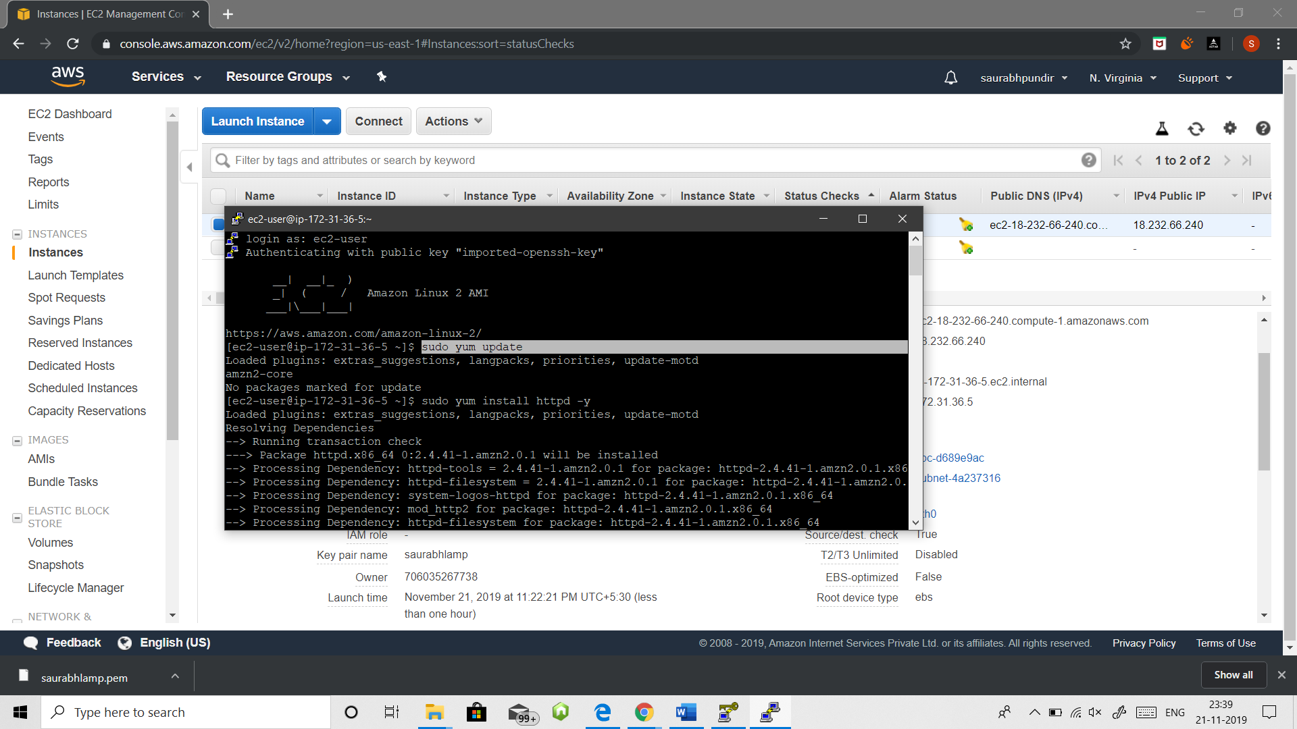

b) sudo yum install httpd -y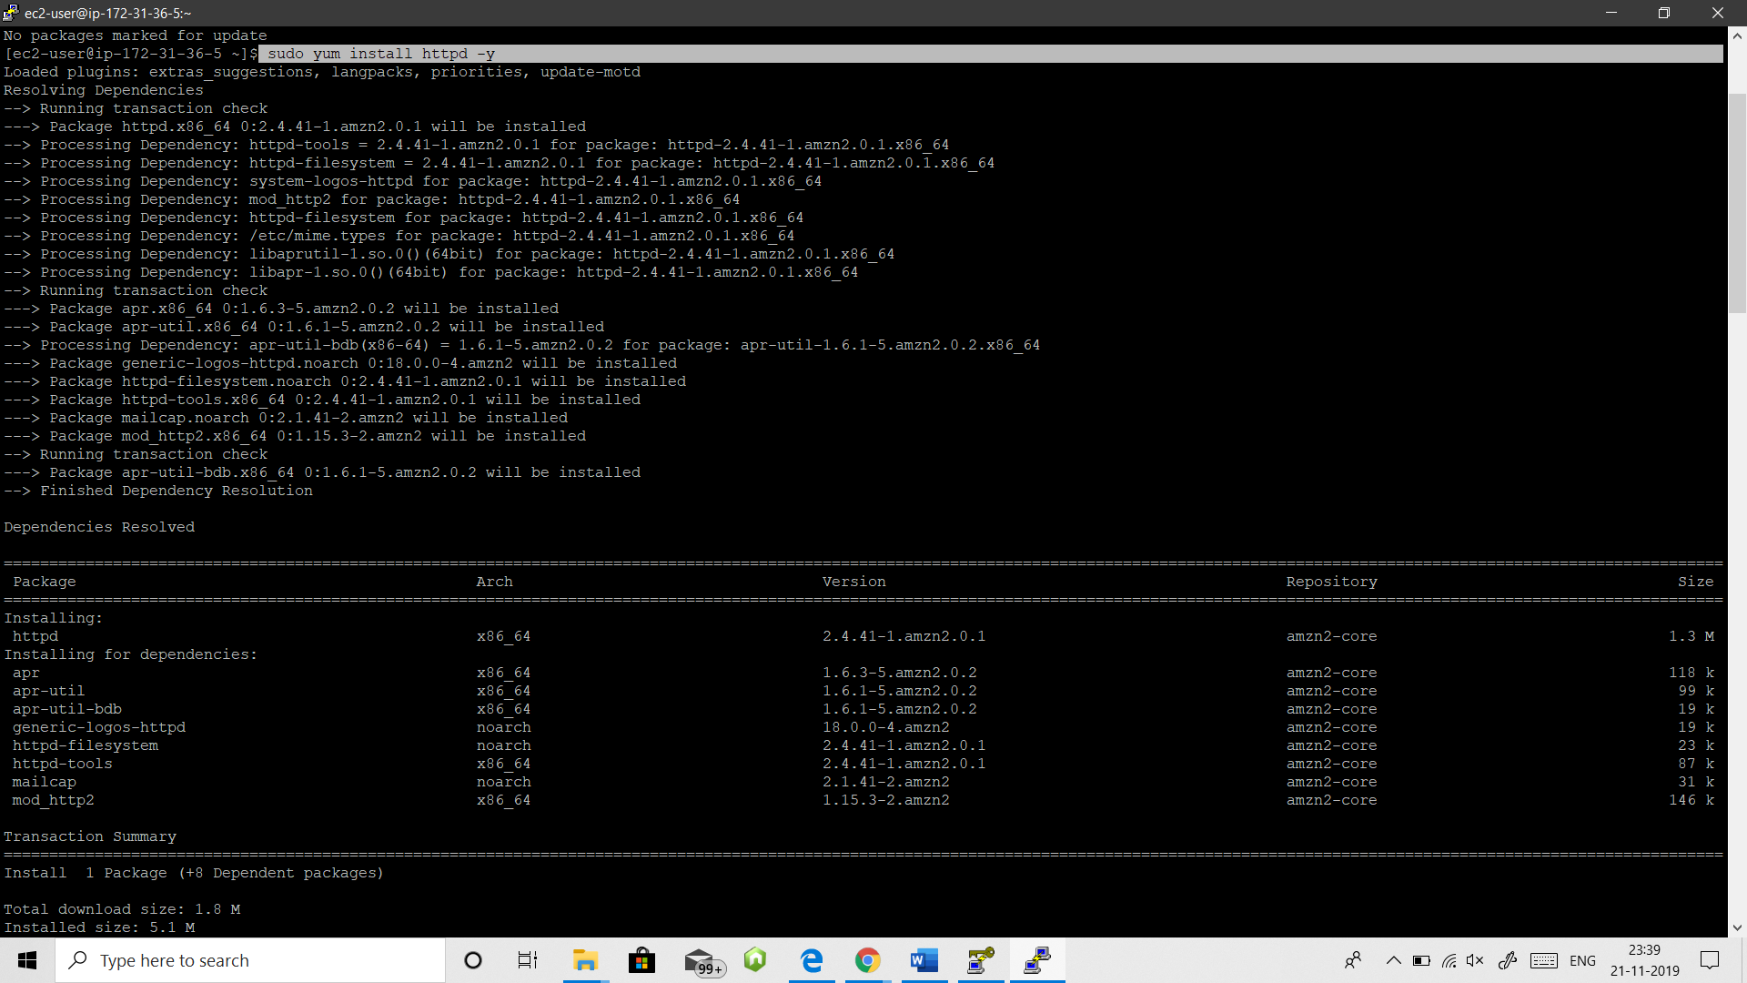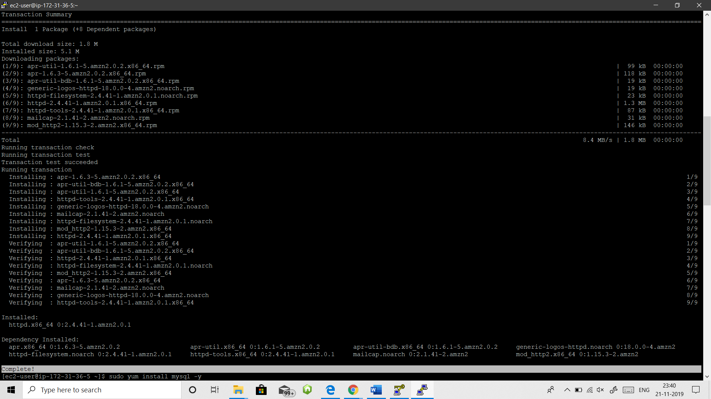

c) sudo yum install MySQL -y

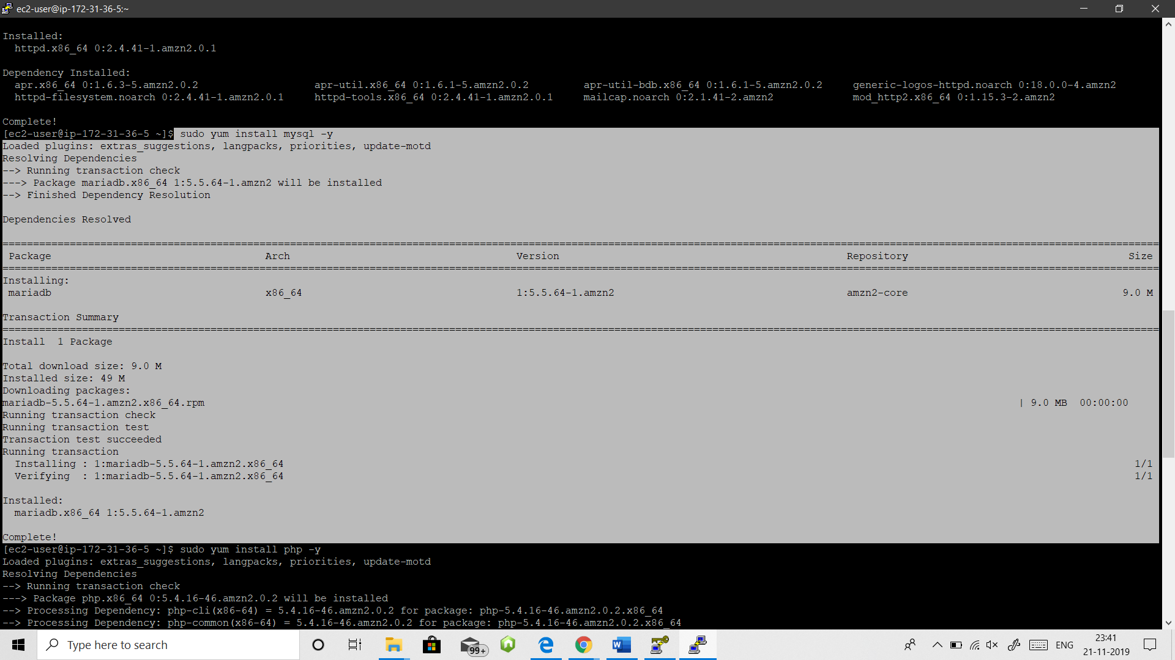

d) sudo yum install php -y

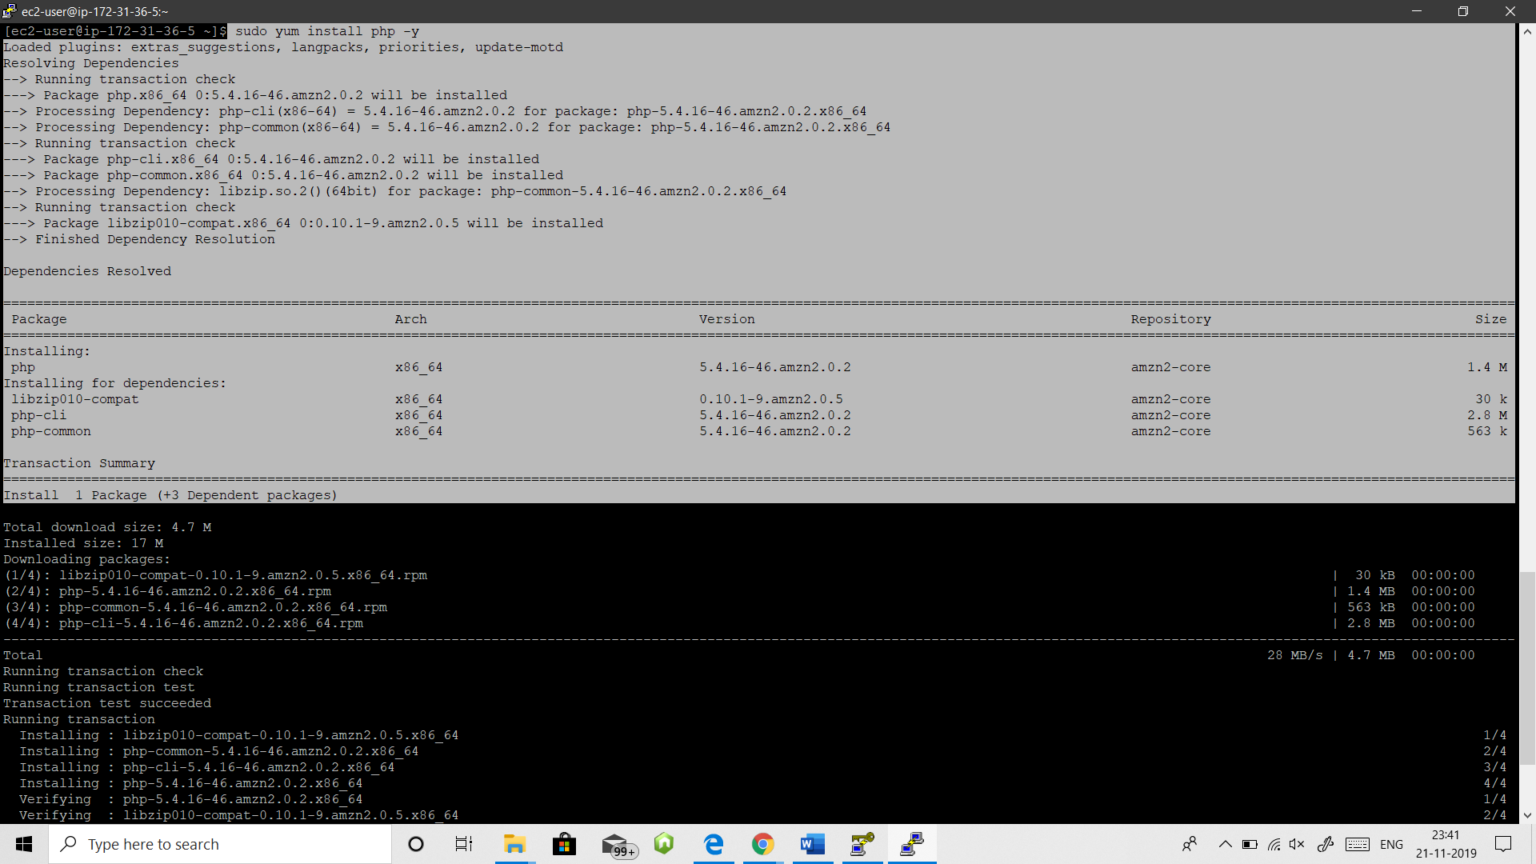

e) sudo service httpd start

sudo chkconfig on

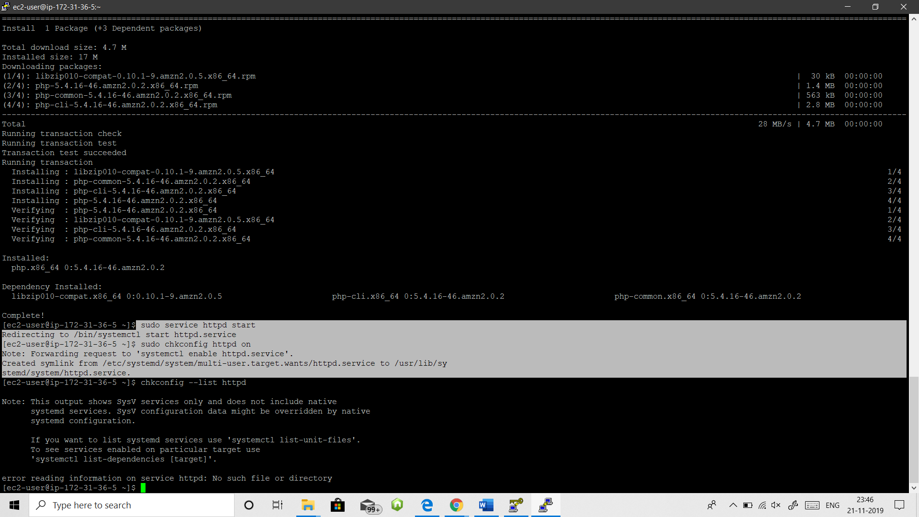

Now check whether service is started or not, for this go to your ipv4

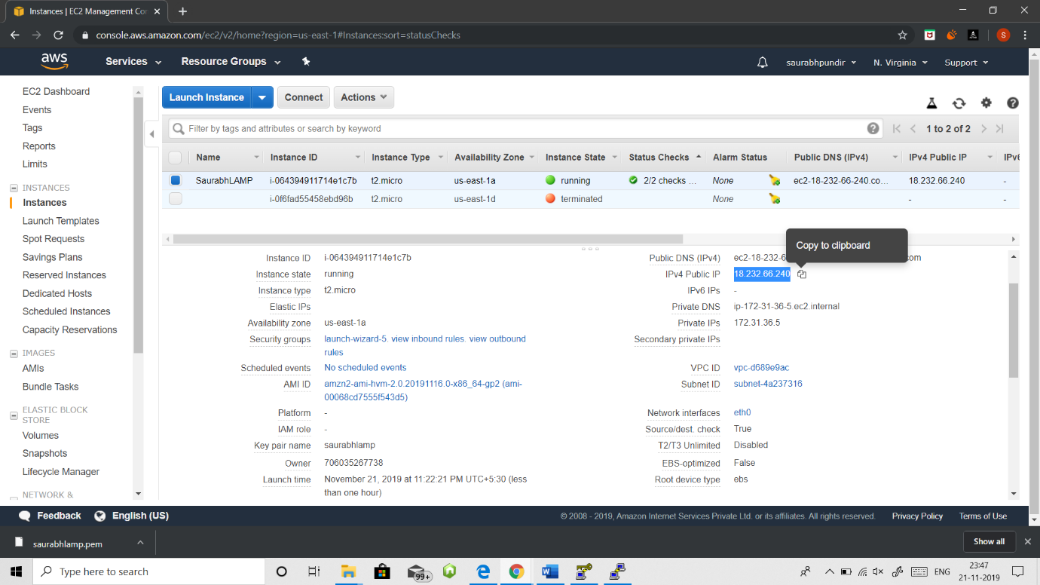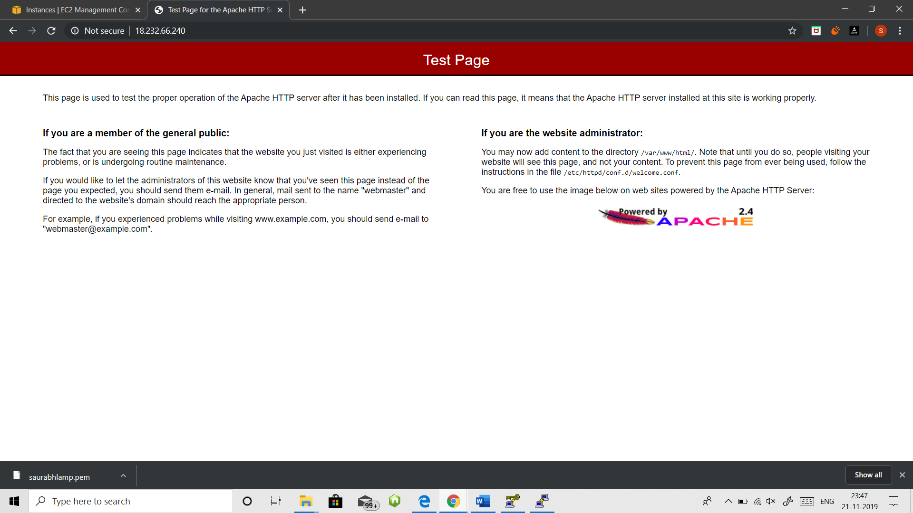

**Creating a Static Website using LAMP server**

1. sudo groupadd www

2. sudo usermod -a -G www ec2-user

**Now leave the current session and open new session**

3. Do the following commands

a) groups

b) sudo chown -R root:www /var/www

c) sudo chmod 2775 /var/www

d) find /var/www -type d -exec sudo chmod 2775 {} \;

e) vi /var/www/html/index.html

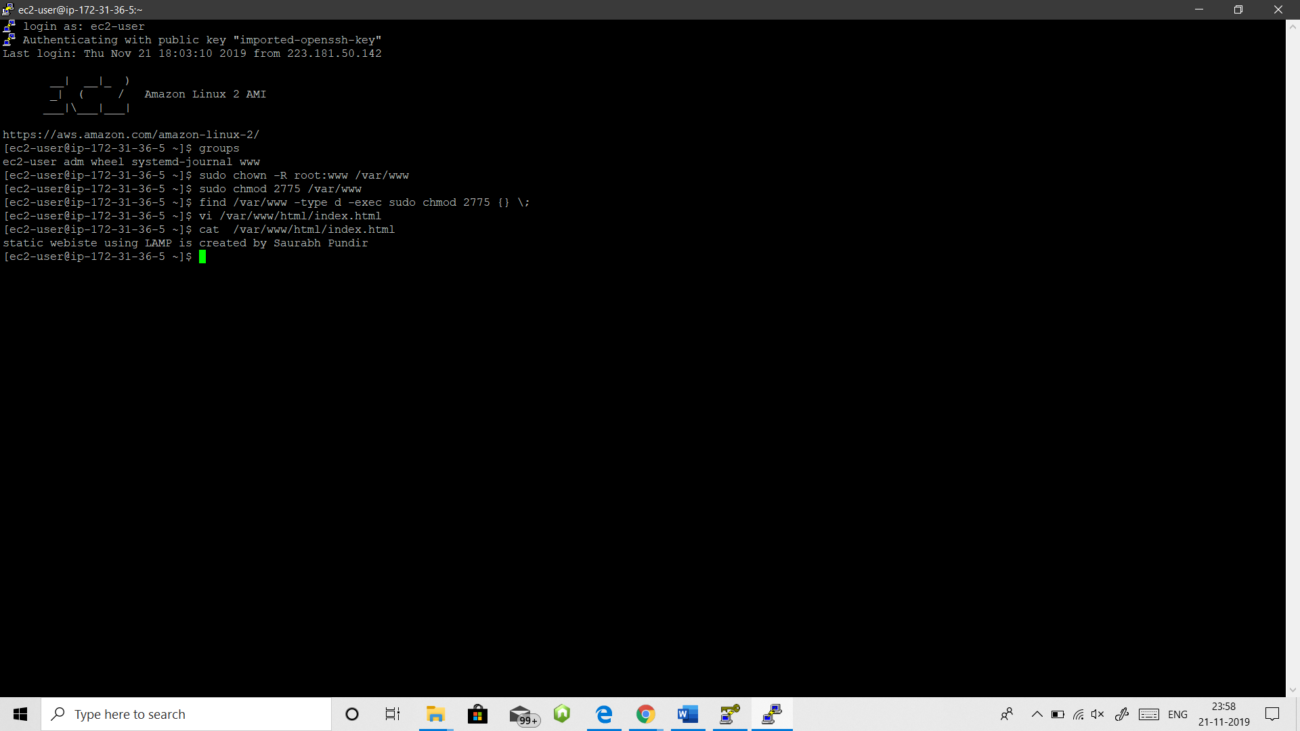

To add content in vi editor use ‘i’ or ‘insert’ button to enter and for exit first press ‘Esc’ button and type ‘:wq’

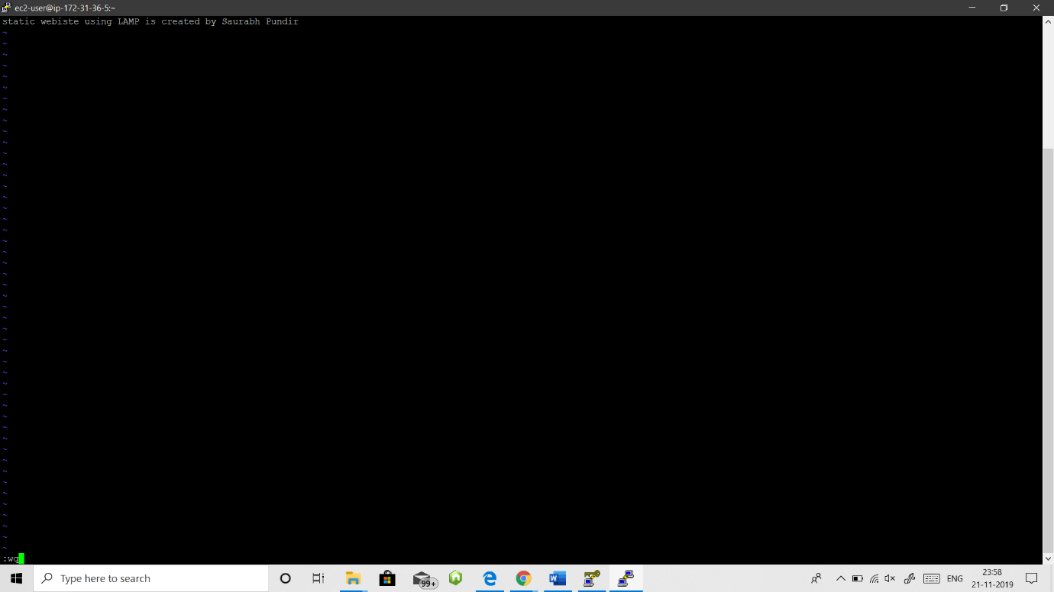

4. Now go your ec2 dashboard and refresh your ipv4 URL tab.

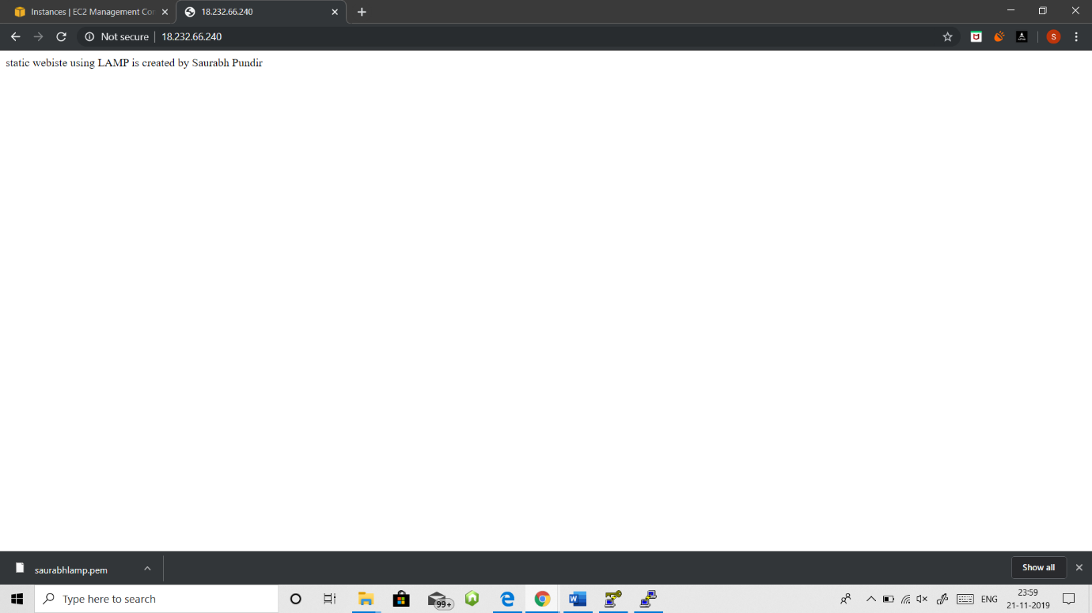

**STATIC WEBSITE USING LAMP LAUNCHED**

**THANK**

**YOU**